# "Mystery Seekers: Urban Legends"

KariAnn Harjo

Master of Science in Software Engineering Capstone Project Proposal

Grand Canyon University

Professor Chintan Thakkar

v2.0

10/23/2024

# Abstract

"Mystery Seekers: Urban Legends" is a detective-themed game developed for the Roblox platform, designed to provide an engaging, story-driven experience where players take on the roles of young detectives solving supernatural mysteries in a modern urban setting. The game is divided into a series of chapters, each presenting a unique mystery that unfolds through player exploration, character interactions, and the strategic collection of clues.  
 The development of this project involves several key tasks: crafting a cohesive multi-chapter storyline, designing immersive and interactive game environments, and implementing complex puzzles and game mechanics that challenge players' problem-solving skills. The project also includes rigorous testing and iterative refinement processes to ensure smooth transitions between scenes and maintain high levels of player engagement (Bou Ghantous & Gill, 2020) .  
 Upon completion, "Mystery Seekers: Urban Legends" will deliver an interactive experience that seamlessly combines elements of mystery, exploration, and problem-solving. The project not only aims to entertain and captivate players with its compelling narrative but also showcases advanced software engineering skills in game design, programming, and user experience development.

# History and Sign-off Sheet

| **HISTORY AND SIGN-OFF SHEET** | | |
| --- | --- | --- |
| ****Date**** | ****Author**** | ****Revision Notes**** |
| 9/18/2024 | KariAnn Harjo | Initial draft for review/discussion |
| 10/20/2024 | KariAnn Harjo | Updated user stories |
| 10/23/2024 | KariAnn Harjo | Final Draft for Milestone 2 Submission |

|  |
| --- |
| **Overall Instructor Feedback/Comments** |

|  |
| --- |
| **Overall Instructor Feedback/Comments** |

**Integrated Instructor Feedback into Project Documentation**

Yes  No

**Project Approval**

*<Insert name of instructor here>*

# Table of Contents

"Mystery Seekers: Urban Legends" 1

Abstract 2

History and Sign-off Sheet 3

Table of Contents 4

Progress Summary: 5

Functional Requirements 6

Non-Functional Requirements 8

Technical Requirements 10

Logical System Design 11

Data Flow Diagram (DFD) 11

Game Flow Overview 12

Entity-Relationship Diagram (ERD) 13

Sequence Diagram 14

User Interface Design 15

Projects Requirements Review 17

Appendix A - References 18

Appendix B 19

#### ****Progress Summary:****

Significant progress has been made on the "Mystery Seekers: Urban Legends" project. Key completed tasks include defining the project scope and objectives, creating a detailed work breakdown structure (WBS), drafting the project timeline, and completing the project proposal document. The foundational elements of the game are well-established, ensuring a clear understanding of the game’s purpose, narrative direction, and critical milestones. Additionally, the detailed design specifications have been further refined, incorporating the development of user stories for both functional and non-functional requirements, logical system design, and the creation of comprehensive diagrams that illustrate game flow, data management, and system interactions.  
 Recently completed tasks include the development of the Logical System Design, which encompasses flowcharts, data flow diagrams, entity-relationship diagrams, and sequence diagrams. These diagrams provide a clear representation of the game’s architecture, detailing the flow of information through the system, player interactions, data handling, and transitions between chapters. The user interface design has also been outlined, including wireframes for key screens such as the main menu, Detective HQ, chapter scenes, and the inventory system, enhancing the visual and functional coherence of the game’s UI.  
 Remaining tasks focus on finalizing the game’s physical design, implementing core game mechanics such as puzzle-solving, NPC interactions, and item collection, and creating immersive game environments for each chapter. Additional work is required to establish security measures, optimize game performance across different devices, and complete the design and implementation of the user interface. Comprehensive testing, including unit, integration, and system testing, will be conducted to ensure the game meets performance and usability standards.  
 The project has faced several challenges, particularly in scripting complex puzzle mechanics, managing data storage efficiently, and optimizing game performance for lower-end devices. To overcome these obstacles, the team has engaged in regular consultations with experienced developers, participated in the Roblox developer community, and conducted extensive research on best practices for performance optimization and puzzle design. Problem-solving strategies such as iterative testing, critical analysis, and continuous refinement have been employed to address these issues, ensuring that the game’s design and functionality align with the project’s goals. Moving forward, the project will continue to utilize these strategies, leveraging developer feedback and technical insights to tackle emerging challenges and achieve successful completion.

# Functional Requirements

The functional requirements for "Mystery Seekers: Urban Legends" outline the core actions and features that the game must deliver to ensure a cohesive and engaging player experience. Key requirements include providing a main hub (Detective HQ) where players can receive clues and start new chapters, enabling interactions with NPCs to gather clues and advance in the game, and implementing automatic saving of player progress. Additional functionalities include solving puzzles to unlock new chapters, collecting items that integrate into gameplay challenges, and providing clear feedback to players upon completing puzzles. The game must also include an intuitive user interface that is easy to navigate, ensuring a smooth gameplay experience across different devices.

| **Functional Requirements** | | | |
| --- | --- | --- | --- |
| ID | User Story | Approval Date | Functional Requirement |
| FR-001 | As a **player**, I want to explore the Detective HQ so that I can receive clues and start new chapters. | [Approval Date] | Provides the main hub for player interaction and narrative progression. |
| FR-002 | As a **player**, I want to interact with NPCs so that I can gather clues and advance in the game. | [Approval Date] | Essential for story progression and player engagement. |
| FR-003 | As a **player**, I want my progress saved automatically so that I can continue from where I left off. | [Approval Date] | Ensures a seamless gaming experience and maintains player engagement across sessions. |
| FR-004 | As a **player**, I want to solve puzzles so that I can unlock new chapters and continue the story. | [Approval Date] | Core gameplay element that drives narrative progression. |
| FR-005 | As a **player**, I want to collect items during gameplay so that I can solve puzzles and advance in the game. | [Approval Date] | Integrates item-based challenges and adds depth to the game’s puzzles. |
| FR-006 | As a **player**, I want to be teleported to new chapters upon completing a puzzle so that I can continue the story. | [Approval Date] | Maintains narrative flow and guides the player through the game’s chapters. |
| FR-007 | As a **player**, I want feedback when I complete a puzzle so that I know I have successfully advanced. | [Approval Date] | Provides positive reinforcement and clear communication of success to the player. |
| FR-008 | As a **player**, I want an intuitive user interface so that I can easily navigate the game and access features. | [Approval Date] | Enhances the overall player experience by making the game more accessible and user-friendly. |
| FR-009 | As a **player**, I want performance optimization on all devices so that I can play without interruptions. | [Approval Date] | Ensures a smooth gameplay experience regardless of device performance capabilities. |
| FR-010 | As a **player**, I want detailed reports on my achievements so that I can track my progress in the game. | [Approval Date] | Encourages replayability and provides players with a sense of accomplishment. |

# Non-Functional Requirements

Non-functional requirements define the system's performance, usability, and reliability standards that must be met to ensure a high-quality user experience. These include fast loading times (under 5 seconds for chapters), optimization for lower-end devices to expand accessibility, secure saving of player data, and maintaining consistent game performance even during high traffic periods. The game must also feature a responsive interface that guides players with clear feedback, robust error handling, and a high availability rate to support continuous access. Furthermore, synchronization of audio and visual elements is essential to enhance the immersive experience.

| **Non-Functional Requirements** | | | |
| --- | --- | --- | --- |
| ID | User Story | Approval Date | Functional Requirement |
| NFR-001 | As a **developer**, I want the game to load chapters in under 5 seconds so that players experience minimal wait times. | [Approval Date] | Ensures fast loading times to maintain player engagement and a seamless experience. |
| NFR-002 | As a **developer**, I want to optimize the game for lower-end devices so that all players can enjoy a smooth gameplay experience. | [Approval Date] | Expands the accessibility of the game to a wider audience, enhancing inclusivity and player retention. |
| NFR-003 | As a **developer**, I want player data to be securely saved so that user progress is not lost and remains private. | [Approval Date] | Protects player information and progress, ensuring compliance with data privacy standards. |
| NFR-004 | As a **developer**, I want the game to maintain consistent performance without lag during high traffic periods. | [Approval Date] | Improves player satisfaction by providing a stable and reliable gaming experience. |
| NFR-005 | As a **developer**, I want the game interface to be intuitive and responsive so that users can easily navigate and interact with the game. | [Approval Date] | Enhances usability, making the game accessible and enjoyable for players of all skill levels. |
| NFR-006 | As a **developer**, I want error handling to be robust and informative so that players understand any issues that occur. | [Approval Date] | Provides players with clear feedback on errors, reducing frustration and guiding them back to gameplay. |
| NFR-007 | As a **developer**, I want the game to be available 99% of the time so that players can access it whenever they want. | [Approval Date] | Ensures high availability of the game, supporting a consistent and reliable player experience. |
| NFR-008 | As a **developer**, I want the game’s audio and visual elements to be synchronized so that the player experience feels cohesive. | [Approval Date] | Enhances the overall immersive quality of the game, aligning audio and visual components for realism. |
| NFR-009 | As a **developer**, I want to minimize memory usage so that the game performs efficiently on various devices. | [Approval Date] | Optimizes the game’s performance, reducing resource consumption and preventing crashes on lower-end devices. |
| NFR-010 | As a **developer**, I want to maintain a secure server connection so that player data integrity is ensured during gameplay. | [Approval Date] | Prevents data loss and maintains consistent player experiences by ensuring stable server connections. |

# Technical Requirements

The technical requirements specify the tools, technologies, and infrastructure needed to develop and maintain the game. The primary platform for development is Roblox Studio, utilizing Lua as the scripting language to implement game logic. The Roblox DataStore service is used to manage player progress and game data, ensuring that information is consistently updated and securely stored. Additionally, asset management within Roblox Studio includes textures, models, and sound effects optimized for performance across various devices. The game’s system architecture is designed with a modular approach, allowing for independent chapter development without disrupting existing gameplay.

| **Technical Requirements** | |
| --- | --- |
| ****Technology or Tool**** | ****Description**** |
| Roblox Studio | Primary platform for game development. |
| Lua | Scripting language used for game logic. |
| DataStore | Used for managing player progress data. |

# Logical System Design

Overall, the Logical System Design encapsulates how "Mystery Seekers: Urban Legends" functions in terms of data flow, player interactions, and system processes. These diagrams collectively provide a comprehensive view of the game’s architecture, guiding developers in constructing a system that meets the functional requirements and delivers a smooth, engaging player experience.

### ****Data Flow Diagram (DFD)****

The Data Flow Diagram details how data moves through the game’s system, focusing on the interaction between player actions, game processes, and data storage components. It identifies key processes, such as the game engine handling player inputs and Lua scripts managing game logic. Data flows illustrate how player progress, inventory updates, and system performance data are captured and stored using Roblox’s DataStore service. This diagram is essential for understanding how data is collected, processed, and utilized within the game, ensuring that information is accurately handled to maintain a consistent player experience.

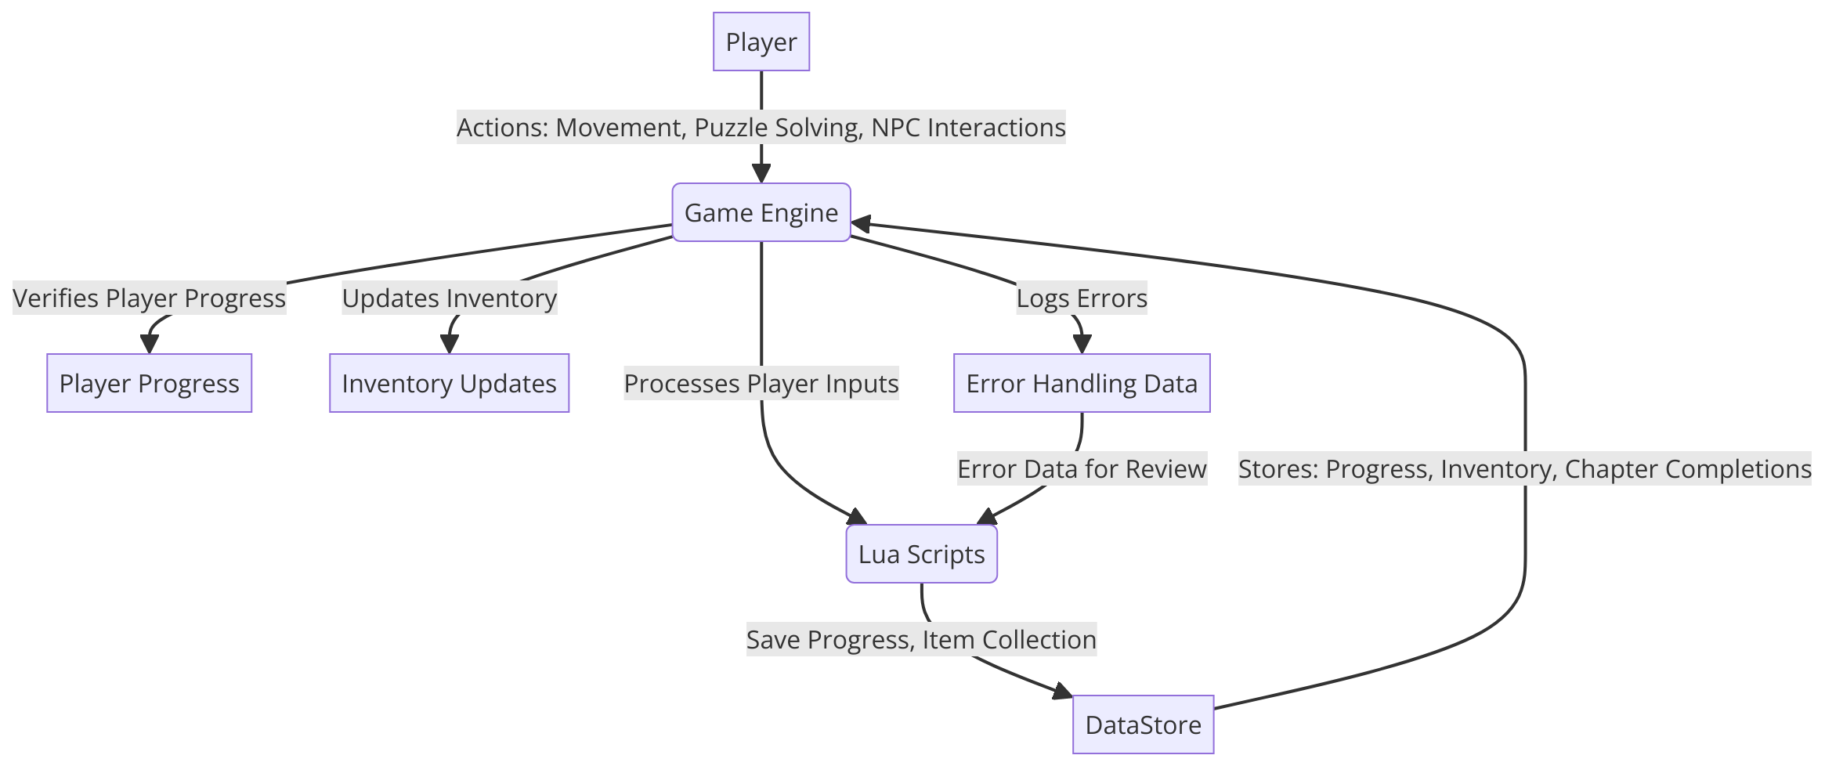Figure 1: Data Flow Diagram

### **Game Flow Overview**

The Game Flow Overview diagram outlines the player’s journey through the game, beginning at the main menu and progressing through various chapters. It highlights key actions, decisions, and transitions that the player experiences, such as interacting with NPCs, solving puzzles, and unlocking new chapters. The flowchart emphasizes the decision points where player choices influence the narrative and gameplay, such as puzzle completions that lead to new chapter access or returning to the Detective HQ for the next clue. This diagram serves as a guide for understanding the sequence of gameplay events and the navigation paths within the game.

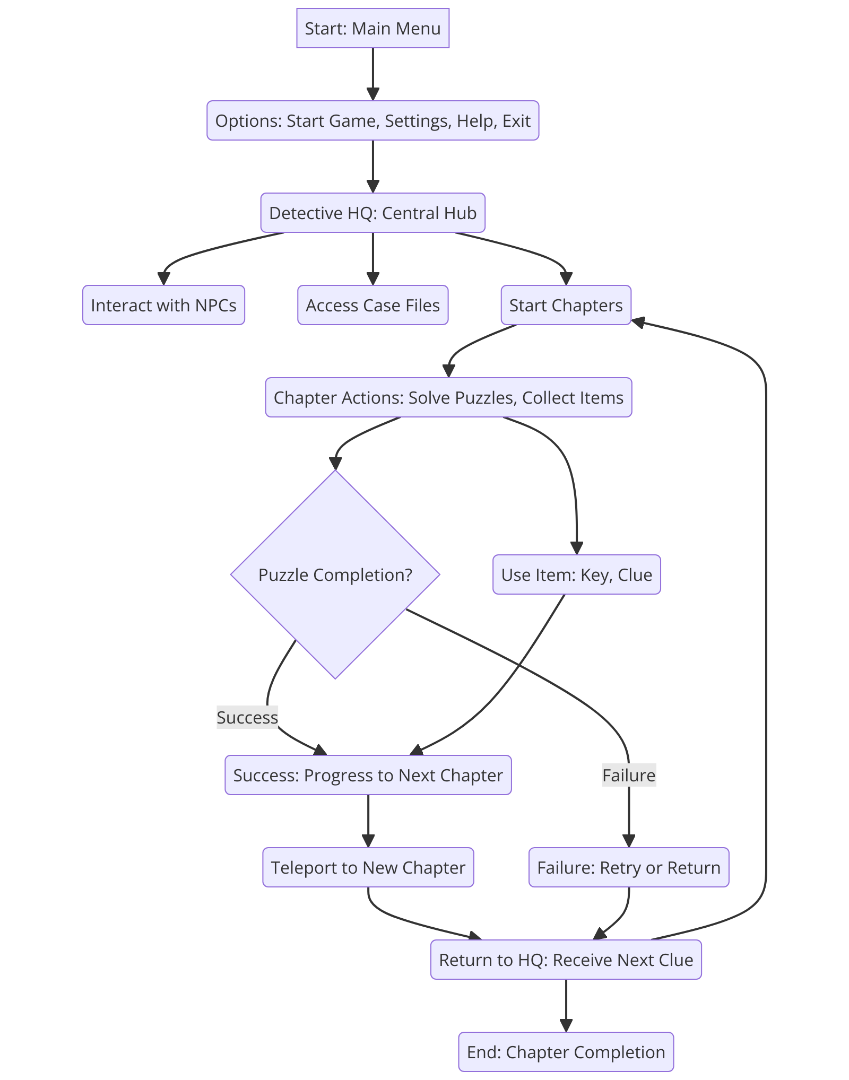Figure 2: Game Flow Overview

### ****Entity-Relationship Diagram (ERD)****

The Entity-Relationship Diagram represents the core data entities within the game and their relationships, including Player, NPC, Chapter, and Item. It maps the connections between these entities, such as how the Player interacts with NPCs to gather clues, completes Chapters to advance the story, and collects Items to solve puzzles. By defining these relationships, the ERD provides a clear understanding of how data entities interact within the system, supporting the logical flow of information needed to manage game mechanics, narrative progression, and player inventory.

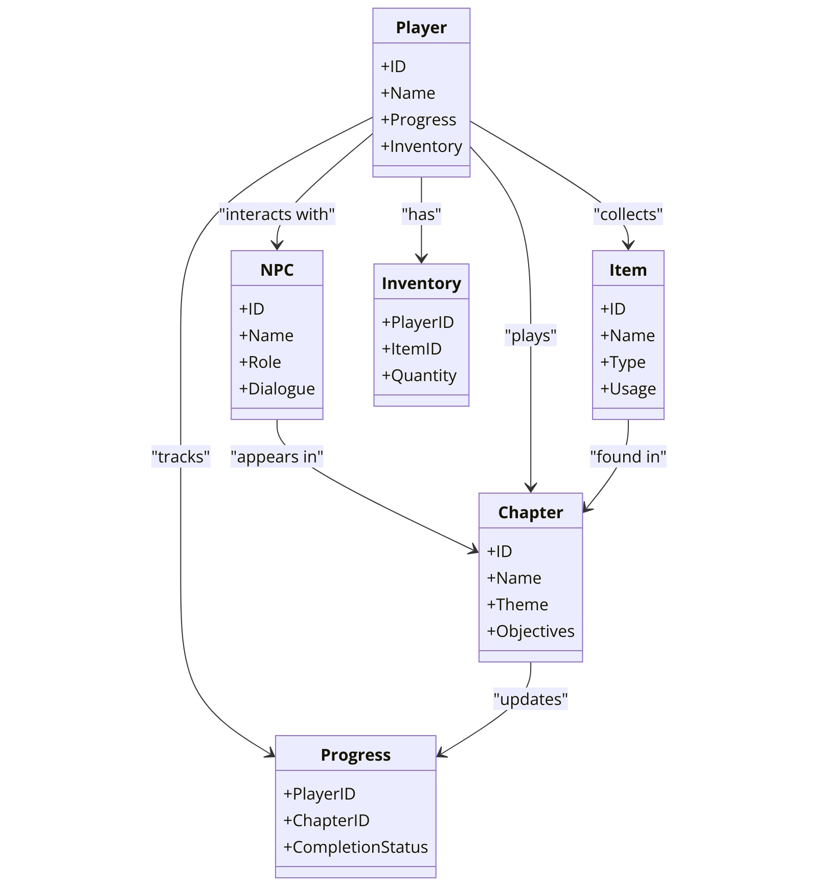

Figure 3: Entity-Relationship Diagram

### ****Sequence Diagram****

The Sequence Diagram visualizes the order of interactions between the player and the game’s system during key gameplay events, such as starting a chapter, saving progress, or completing a puzzle. It shows the communication flow between the Player, Game Interface, Game Logic (Lua Scripts), and DataStore, detailing how each component responds to player inputs. This diagram emphasizes the timing and sequence of actions, ensuring that the game logic aligns with the player’s expectations and system requirements, such as immediate feedback upon puzzle completion or real-time data updates.

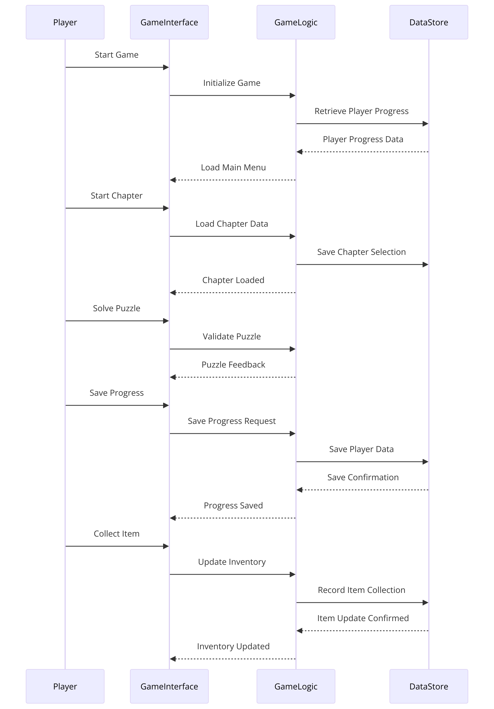

Figure 4: Sequence Diagram

# User Interface Design

**Sitemap:** The game’s user interface is structured around the central hub (Detective HQ) and various chapters. Below is the sitemap outlining the key screens and their navigation flow:

1. **Main Menu**
   * Options: Start Game, Settings, Help, Exit
2. **Detective HQ (Central Hub)**
   * Access to:
     + Case Files (start chapters)
     + Inventory
     + NPC Interactions (Clues and Missions)
3. **Chapter Screens (Place 1 to Place 5)**
   * Each chapter screen has interactive elements such as puzzles, NPCs, and collectable items.
4. **Inventory Screen**
   * View collected items, clues, and progress.
5. **Settings Screen**
   * Adjust audio, controls, and display settings.
6. **Pause Menu (Accessible during gameplay)**
   * Resume, Restart Chapter, Settings, Main Menu

**Wireframe Designs for Key Screens:**

1. **Main Menu Wireframe**
   * **Title**: Game Title prominently displayed at the top.
   * **Toolbars**: Side toolbar with icons for Settings, Help, and Exit.
   * **Buttons**: Large buttons for Start Game, Settings, and Exit centered on the screen.
   * **Look and Feel**: Dark, mysterious background with subtle animations to set the theme.
2. **Detective HQ (Central Hub) Wireframe**
   * **Title**: "Detective HQ"
   * **Toolbars**: Inventory icon in the top corner, mission log icon for accessing current tasks.
   * **NPC Interaction Zones**: Highlighted clickable areas for NPCs that provide clues and missions.
   * **Text Fields**: Dialogue boxes for NPC conversations.
   * **Content**: Text prompts and clues, visual hints related to the next chapter.
3. **Chapter Screen (Generic Layout)**
   * **Title**: "Chapter [Number] – [Chapter Name]"
   * **Content**: Scene layout with interactive elements (puzzles, items).
   * **Text Fields**: Tooltips when hovering over interactive objects.
   * **Toolbars**: Access to pause menu, chapter objectives.
   * **Look and Feel**: Chapter-specific themes (e.g., school, park) with appropriate ambient visuals and sound effects.
4. **Inventory Screen Wireframe**
   * **Title**: "Inventory"
   * **Content**: Grid layout showing collected items, each with icons and descriptions.
   * **Text Fields**: Detailed descriptions when selecting an item.
   * **Toolbars**: Options to sort items or return to the previous screen.
   * **Look and Feel**: Consistent with the detective theme, with dark tones and subtle animations for interactions.
5. **Settings Screen Wireframe**
   * **Title**: "Settings"
   * **Toolbars**: Tabs for Audio, Controls, Display.
   * **Date Entry Fields**: Sliders and checkboxes for adjusting settings.
   * **Text Fields**: Descriptions for each setting option.
   * **Look and Feel**: Clean, functional layout that maintains the game's overall theme.
6. **Pause Menu Wireframe**
   * **Title**: "Paused"
   * **Buttons**: Resume, Restart Chapter, Main Menu.
   * **Text Fields**: Current chapter and progress displayed.
   * **Look and Feel**: Semi-transparent overlay with clear, easy-to-read options.

**Overall Look and Feel:** The user interface design for "Mystery Seekers: Urban Legends" is tailored to match the mysterious and investigative theme of the game. Dark, moody colors with pops of light highlight key elements, drawing the player's attention to interactive components. The UI maintains a balance between functional accessibility and thematic immersion, ensuring that players are always engaged and never overwhelmed. Each screen is designed to provide intuitive navigation, helping players focus on solving the mysteries at hand.

# Projects Requirements Review

Before submitting the milestone deliverable for "Mystery Seekers: Urban Legends," a comprehensive review of prior milestones was conducted to ensure consistency and alignment with the project’s objectives. This process involved revisiting the initial proposal and comparing it to the current progress to verify that the project remains true to its original vision and scope.

Several adjustments were made during this review process to maintain coherence across all project documentation. For example, the functional and non-functional requirements were refined to better reflect the evolving complexity of the game’s mechanics, such as the addition of more intricate puzzle designs and enhanced NPC interactions. Additionally, the logical system design has been adjusted to ensure optimal data flow and performance as new features are integrated.

# Appendix A - References

**Andersen, K. A., Grozev, G., Chapman, J., & Pedersen, T. K. (2018).** A classification of replicated data for the design of web applications. Journal of Web Engineering, 17(2), 121-144.  
  
**Bass, L., Clements, P., & Kazman, R. (2021).** Software architecture in practice **(4th ed.). Addison-Wesley Professional.  
  
Blake, M. B., Ranabahu, A., & Gomadam, K. (2008).** Synergizing domain expertise with self-awareness in software systems: A patternized architecture guideline. IEEE Internet Computing, 12(4), 71-77. <https://doi.org/10.1109/MIC.2008.86>  
  
Cui, Y., Zada, I., Shahzad, S., Nazir, S., Khan, S. U., Hussain, N., & Asshad, M. (2021). Analysis of service-oriented architecture and Scrum software development approach for IIoT. Scientific Programming, 2021, Article ID 6611407, 14 pages. <https://doi.org/10.1155/2021/6611407>  
  
Creative Commons. (n.d.). About The Licenses. Retrieved August 21, 2024, from <https://creativecommons.org/licenses/>  
  
GitHub, Inc. (n.d.). GitHub Terms of Service. Retrieved August 21, 2024, from https://docs.github.com/en/site-policy/github-terms/github-terms-of-service

Holman Bible Publishers. (2017). Holy Bible: Version Title. Holman Bible Publishers.

**Lenk, A., & Klems, M. (2009).** Chapter 17: Understanding the Cloud Computing Stack. In Cloud Computing (pp. 159-181). Springer. <https://doi.org/10.1007/978-1-4419-6876-3_17>  
  
Radziwill, N. (2019). Quality Considerations for Ethical Design of Virtual and Augmented Reality. Software Quality Professional, 21(4), 34-47.

Roblox Corporation. (n.d.). Terms of Use. Retrieved August 21, 2024, from https://en.help.roblox.com/hc/en-us/articles/115004630823